## 

coursemash

**collaborationweb-application**

*Created by Kiondra Mills*

*Date: 05.07.2019*

Document Prepared by Kiondra Mills - *Software Engineer, graduate student*

Regis University - M.S. Software Engineering

Table of Contents

**Abstract 3**

**Initial Design Goals 5**

**High-Level Requirements Overview 5**

**Prioritized Use Case 6**

**Use Case Diagram 7**

**Envisioned Architecture 8**

**Common Good Computing Considerations 9**



Introduction

# 

# Abstract

CourseMash is a community-based collaboration web application software designed for students. When it comes to studying whether it’s online or on campus in a classroom, connecting with fellow students in today’s busy world can often be a challenge especially when taking online classes. CourseMash is a platform that offers students the ability to be able to communicate with each other through chat forums, the ability form private study groups, share documents for group projects, share success tips for future students new to the class, and when feeling overwhelmed even alert other students when they need help. Users can view sample project ideas from previous students to help stimulate their creative juices. CourseMash users will be able to login to the web app through their school email address, access courses based on the university, course name and number. Due to the fact that often times no two professors teach the same nor have the course structured the same, the courses are also grouped by professors. CourseMash aims to create a positive free interactive space where students can come together and offer support for each. All of the data within CourseMash is user-generated and user maintained. Students can access and participate in multiple courses at a time.

# 

# 

# 

**designgoals**

# Initial Design Goals

In its infancy, the CourseMash software application will have the basics of all CRUD operations. All users will be authenticated through a university email address only. CourseMash users will be able to create a unique course channel, create, read, update, and delete their channel post in the chat forum. Users will also be able to upload a document or everyone to view. If time permits CourseMash users will also be able to create private chat forums for study groups, as well as send *help alerts* to everyone within the course.

# High-Level Requirements Overview

* **Register a user.** 
  + User registers using university email, username & password.
  + Email is validated to ensure its correct format, unique, and a university-based email address.
* **Authenticate user.**
  + User signs in using email & password.
  + A forgot password link appears if user authentication fails. *(If time permits)*
  + Email is sent to reset the password. *(If time permits)*
* **Create Course channel.**
  + **Create a course.**
    1. Once signed in a user can create a course channel. Note there is no owner of the channel so any user can add/edit information within the channel.
    2. The Initial creator of the channel adds the basic channel information.
       1. Course name, Course number, Associated Instructor.
  + **Course Invite.** *(If time permits)*
    1. Users can invite other students to participate in the course forum.
  + **Creat/Read/Edit/Delete Chat Post.**
    1. Authenticated users can create/edit/delete post within the general section of the chat forum.
    2. Users can create and send a private message to another user. *(If time permits)*
  + **Document share.**
  + Users will be able to upload documents to share on the forum.
  + **Send private messages.**
  + **Create private groups.**
  + **Help Alert.**
    1. Users will be able to send a help alert to all users within the course.

# PRIORITIZED USER USE CASE

## **REGISTER USER**

## **AUTHENTICATE USER**

## **CREATE COURSE CHANNEL**

## **CREATE, READ, EDIT, & DELETE CHAT POST**

## **USER DOCUMENT SHARE**

## **CREATE PRIVATE GROUPS**

## **SEND PRIVATE MESSAGE**

1. **SEND HELP ALERTS**

# 

# USE CASE DIAGRAM

**

# 

# Envisioned Architecture

**{ A FULL STACK SOFTWARE APPLICATION }**



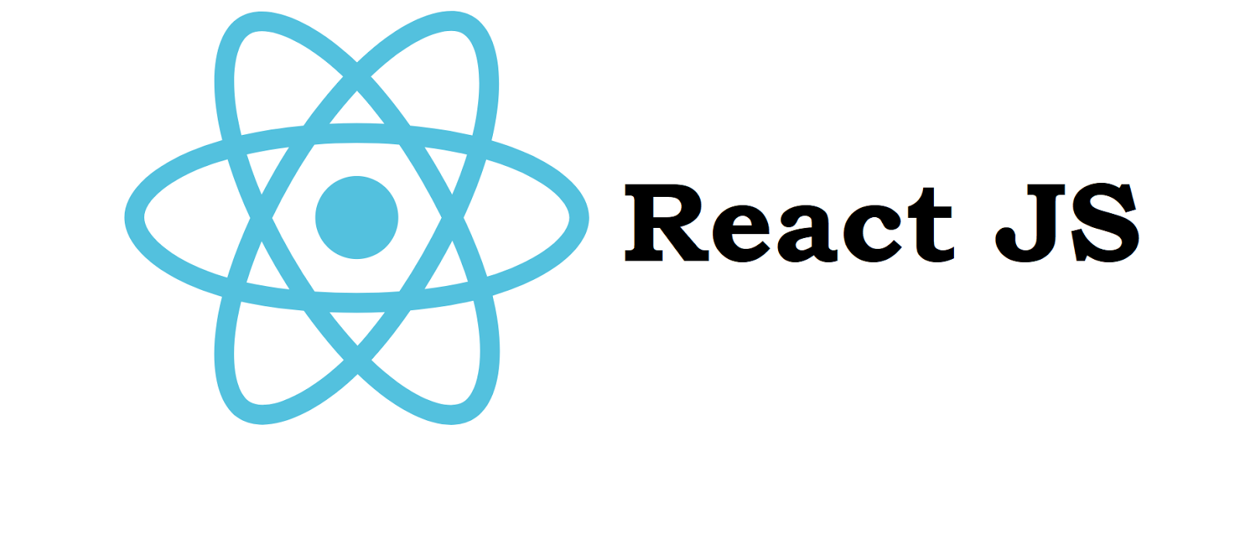



# Common Good Computing Considerations

Learning in an online environment can be quite challenging. Often times one of the biggest challenges live in the lack of communication between students and their peers, leaving many students a feeling of being socially left out and alone. CourseMash hopes to provide a space for students to communicate and collaborate on courses, in hopes of make the lives of online students a little easier and more manageable:-)

.